|  |  |
| --- | --- |
| Natural Resource Coal | Natural Resource Oil |
| Natural Resource Metal | Natural Resource Rocks |

|  |  |
| --- | --- |
| Natural Resource Animals | Natural Resource Plants |
| Natural Resource Air | Natural Resource Water |

Natural Resources come from the Earth. What do you think would happen if we lost some of our natural resources? Place a natural resource card below and then describe what would happen if we did not have it anymore.

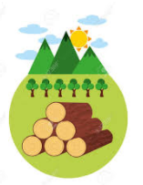

_________________________________________________________________________________________________________________________________________________________________________________

There are two types of natural resources. Resources that we can get repeatedly and resources that take a long time to produce.

Do you think you can sort the resources into the two groups?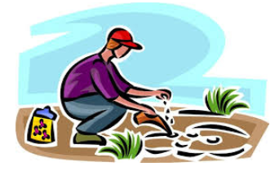

Place all of the resources here that we can get over and over again.

Place all of the resources here that take a long time to produce.

|  |  |  |  |
| --- | --- | --- | --- |
| plants | plants | animal | animal |
| oil | oil | drinking water | Faucet water |
| coal | coal | Wind energy | windsock |
| Rock salt | Rock concrete | Metal building | Metal tool |

Objects made from natural resources.

|  |  |  |  |
| --- | --- | --- | --- |
|  |  |  |  |
|  |  |  |  |
|  |  |  |  |
|  |  |  |  |

Place a natural resource card in the big box below. Then identify two objects that are made from or that can be used because of the resource.

What would happen if we did not have this resource?

What can we do to ensure that we never run out of this resource?

We have to conserve natural resources in order to protect them.

Place a picture of a natural resource below and come up with an invention that will help us conserve it.

Describe how your invention will conserve this resource. ______________________________________________________________________________________________________________________________________________________________________________________________________________________________________________________________________________________________________________________________________________________________________________________________________________________________________________________________________________________________________________________________________________________________________________________________________________________________________________________________________________________________________________________________________________________________________________________________________________________________________________________________________________________________________________________________________________________________





One of the reasons it is hard to conserve natural resources is because we use them to make so many things. Look at the pictures of things made by natural resources. How could we do things differently to save some of the resources?

__________________________________________________________________________________________________________________________________________________________________________________________________________________________________________________________________________________________________________________________________________________________________________________________________________________________________________________________________________________________________________________________________________________

__________________________________________________________________________________________________________________________________________________________________________________________________________________________________________________________________________________________________________________________________________________________________________________________________________________________________________________________________________________________________________________________________________________

__________________________________________________________________________________________________________________________________________________________________________________________________________________________________________________________________________________________________________________________________________________________________________________________________________________________________________________________________________________________________________________________________________________



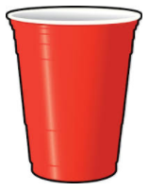

One of the reasons it is hard to conserve natural resources is because we use them to make so many things. Look at the pictures of things made by natural resources. How could we do things differently to save some of the resources?

__________________________________________________________________________________________________________________________________________________________________________________________________________________________________________________________________________________________________________________________________________________________________________________________________________________________________________________________________________________________________________________________________________________

__________________________________________________________________________________________________________________________________________________________________________________________________________________________________________________________________________________________________________________________________________________________________________________________________________________________________________________________________________________________________________________________________________________

__________________________________________________________________________________________________________________________________________________________________________________________________________________________________________________________________________________________________________________________________________________________________________________________________________________________________________________________________________________________________________________________________________________





One of the reasons it is hard to conserve natural resources is because we use them to make so many things. Look at the pictures of things made by natural resources. How could we do things differently to save some of the resources?

__________________________________________________________________________________________________________________________________________________________________________________________________________________________________________________________________________________________________________________________________________________________________________________________________________________________________________________________________________________________________________________________________________________

__________________________________________________________________________________________________________________________________________________________________________________________________________________________________________________________________________________________________________________________________________________________________________________________________________________________________________________________________________________________________________________________________________________

__________________________________________________________________________________________________________________________________________________________________________________________________________________________________________________________________________________________________________________________________________________________________________________________________________________________________________________________________________________________________________________________________________________